1. Plot the dotplot for the word ABRACADABRACADABRA against itself, put a dot whenever there's a single letter match. What can you say about the internal structure of the analyzed word? Do you see any repeated pattern? Can you locate palindromes?
 | A | B | R | A | C | A | D | A | B | R | A | C | A | D | A | B | R | A
A
B
R
A
C
A
D
A
B
R
A
C
A
D
A
B
R
A
2. Repeat exercise 2, using WINDOW size = 3, STEP = 1, and STRINGENCY = 2. Put a dot at the middle position of each triplet that meets stringency criteria. Did you get the same pattern? Is it more clear now?

 | A | B | R | A | C | A | D | A | B | R | A | C | A | D | A | B | R | A
A
B
R
A
C
A
D
A
B
R
A
C
A
D
A
B
R
A

3. Download BLOSUM62 and PAM250 matrices to your computer from NCBI ftp site: ftp://ftp.ncbi.nih.gov/blast/matrices/.
For each matrices that you downloaded which substitution is more probable, W<->F or H<->Q?

4. What is the identity percentage between the words DECLENSION and RECREATION? (assume ungapped alignment)

5. Calculate a similarity score for the above alignment using
a) BLOSUM62 matrix
b) PAM250 matrix
In case a letter is not represented in the matrix assume STOP (*)

6. Create an alignment of two phrases based on the presented path. Calculate the score of the alignment using BLOSUM62 matrix and affine gap penalty as follow: gap opening -11, gap extension -1.

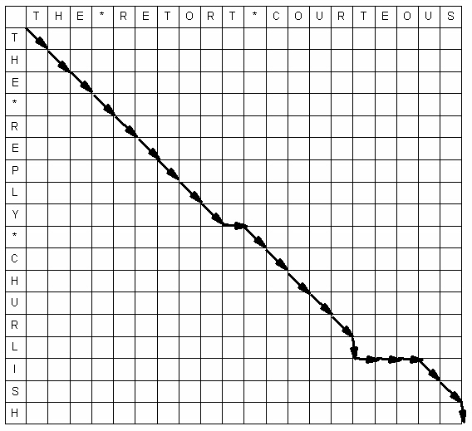

 Michael Crichton's fantasy about cloning dinosaurs, Jurassic Park, contains a putative dinosaur DNA sequence. Use nucleotide-nucleotide BLAST against the default nucleotide database, nr, to identify the real source of the following sequence. Select, copy and paste it into the BLAST form window. This is probably the most common use of nucleotide-nucleotide BLAST: sequence identification or does this exact sequene already exist in the database? For your results provide following information: a) accession number of the best hit b) what molecule does the subject sequence represent? c) what is the function of the subject molecule? d) is it natural molecule? e) use dot-plot program to compare the primary structure of the "Dino" sequence and its best hit, what kind of modification did Michael Crichton introduced?

>DinoDNA "Dinosaur DNA" from Crichton's JURASSIC PARK p. 103 nt 1-1200 GCGTTGCTGGCGTTTTTCCATAGGCTCCGCCCCCCTGACGAGCATCACAAAAATCGACGC GGTGGCGAAACCCGACAGGACTATAAAGATACCAGGCGTTTCCCCCTGGAAGCTCCCTCG TGTTCCGACCCTGCCGCTTACCGGATACCTGTCCGCCTTTCTCCCTTCGGGAAGCGTGGC TGCTCACGCTGTACCTATCTCAGTTCGGTGTAGGTCGTTCGCTCCAAGCTGGGCTGTGTG CCGTTCAGCCCGACCGCTGCGCCTTATCCGGTAACTATCGTCTTGAGTCCAACCCGGTAA AGTAGGACAGGTGCCGGCAGCGCTCTGGGTCATTTTCGGCGAGGACCGCTTTCGCTGGAG ATCGGCCTGTCGCTTGCGGTATTCGGAATCTTGCACGCCCTCGCTCAAGCCTTCGTCACT CCAAACGTTTCGGCGAGAAGCAGGCCATTATCGCCGGCATGGCGGCCGACGCGCTGGGCT GGCGTTCGCGACGCGAGGCTGGATGGCCTTCCCCATTATGATTCTTCTCGCTTCCGGCGG CCCGCGTTGCAGGCCATGCTGTCCAGGCAGGTAGATGACGACCATCAGGGACAGCTTCAA CGGCTCTTACCAGCCTAACTTCGATCACTGGACCGCTGATCGTCACGGCGATTTATGCCG CACATGGACGCGTTGCTGGCGTTTTTCCATAGGCTCCGCCCCCCTGACGAGCATCACAAA CAAGTCAGAGGTGGCGAAACCCGACAGGACTATAAAGATACCAGGCGTTTCCCCCTGGAA GCGCTCTCCTGTTCCGACCCTGCCGCTTACCGGATACCTGTCCGCCTTTCTCCCTTCGGG CTTTCTCAATGCTCACGCTGTAGGTATCTCAGTTCGGTGTAGGTCGTTCGCTCCAAGCTG ACGAACCCCCCGTTCAGCCCGACCGCTGCGCCTTATCCGGTAACTATCGTCTTGAGTCCA ACACGACTTAACGGGTTGGCATGGATTGTAGGCGCCGCCCTATACCTTGTCTGCCTCCCC GCGGTGCATGGAGCCGGGCCACCTCGACCTGAATGGAAGCCGGCGGCACCTCGCTAACGG CCAAGAATTGGAGCCAATCAATTCTTGCGGAGAACTGTGAATGCGCAAACCAACCCTTGG CCATCGCGTCCGCCATCTCCAGCAGCCGCACGCGGCGCATCTCGGGCAGCGTTGGGTCCT

8. Mark Boguski of the NBCI noticed this and supplied Crichton with a better sequence, shown below, for the sequel, The Lost World. Identify the most likely source of this sequence using nucleotide-nucleotide BLAST. Mark imbedded a message in the sequence he provided. To see Mark's message use the translating BLAST (blastx) page with the sequence below. TIP: to better see the message switch off "masking" and limit number of alignments to one; you will need to use "advanced options" window with the following syntax -b 1 and E-value 1e-50.

>DinoDNA "Dinosaur DNA" from Crichton's THE LOST WORLD p. 135 GAATTCCGGAAGCGAGCAAGAGATAAGTCCTGGCATCAGATACAGTTGGAGATAAGGACG GACGTGTGGCAGCTCCCGCAGAGGATTCACTGGAAGTGCATTACCTATCCCATGGGAGCC ATGGAGTTCGTGGCGCTGGGGGGGCCGGATGCGGGCTCCCCCACTCCGTTCCCTGATGAA GCCGGAGCCTTCCTGGGGCTGGGGGGGGGCGAGAGGACGGAGGCGGGGGGGCTGCTGGCC TCCTACCCCCCCTCAGGCCGCGTGTCCCTGGTGCCGTGGGCAGACACGGGTACTTTGGGG ACCCCCCAGTGGGTGCCGCCCGCCACCCAAATGGAGCCCCCCCACTACCTGGAGCTGCTG CAACCCCCCCGGGGCAGCCCCCCCCATCCCTCCTCCGGGCCCCTACTGCCACTCAGCAGC GGGCCCCCACCCTGCGAGGCCCGTGAGTGCGTCATGGCCAGGAAGAACTGCGGAGCGACG GCAACGCCGCTGTGGCGCCGGGACGGCACCGGGCATTACCTGTGCAACTGGGCCTCAGCC TGCGGGCTCTACCACCGCCTCAACGGCCAGAACCGCCCGCTCATCCGCCCCAAAAAGCGC CTGCTGGTGAGTAAGCGCGCAGGCACAGTGTGCAGCCACGAGCGTGAAAACTGCCAGACA TCCACCACCACTCTGTGGCGTCGCAGCCCCATGGGGGACCCCGTCTGCAACAACATTCAC GCCTGCGGCCTCTACTACAAACTGCACCAAGTGAACCGCCCCCTCACGATGCGCAAAGAC GGAATCCAAACCCGAAACCGCAAAGTTTCCTCCAAGGGTAAAAAGCGGCGCCCCCCGGGG GGGGGAAACCCCTCCGCCACCGCGGGAGGGGGCGCTCCTATGGGGGGAGGGGGGGACCCC TCTATGCCCCCCCCGCCGCCCCCCCCGGCCGCCGCCCCCCCTCAAAGCGACGCTCTGTAC GCTCTCGGCCCCGTGGTCCTTTCGGGCCATTTTCTGCCCTTTGGAAACTCCGGAGGGTTT TTTGGGGGGGGGGCGGGGGGTTACACGGCCCCCCCGGGGCTGAGCCCGCAGATTTAAATA ATAACTCTGACGTGGGCAAGTGGGCCTTGCTGAGAAGACAGTGTAACATAATAATTTGCA CCTCGGCAATTGCAGAGGGTCGATCTCCACTTTGGACACAACAGGGCTACTCGGTAGGAC CAGATAAGCACTTTGCTCCCTGGACTGAAAAAGAAAGGATTTATCTGTTTGCTTCTTGCT GACAAATCCCTGTGAAAGGTAAAAGTCGGACACAGCAATCGATTATTTCTCGCCTGTGTG AAATTACTGTGAATATTGTAAATATATATATATATATATATATATCTGTATAGAACAGCC TCGGAGGCGGCATGGACCCAGCGTAGATCATGCTGGATTTGTACTGCCGGAATTC

